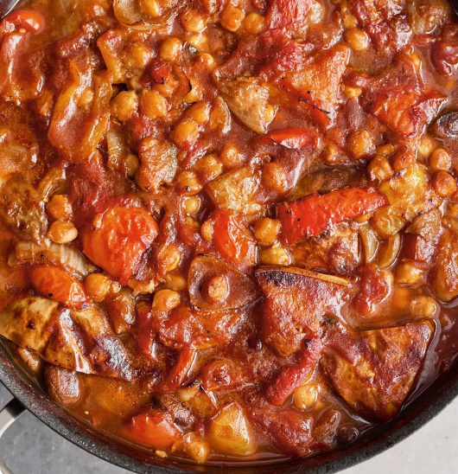
Veggie casserole (V)
serves 12 Kcals 181 fibre 8g
- 1 butternut squash (1.2kg)
- 400g chestnut mushrooms
- 4 onions
- 4 mixed-colour peppers
- 2 cloves of garlic
- olive oil
- red wine vinegar
- 2 tablespoons black olive tapenade
- 4 x 400g tins of chickpeas
- 2 x 400g tins of plum tomatoes

- Preheat the oven to 180°C/350°F/gas 4.
- Wash and trim the squash (there’s no need to peel it), carefully halve lengthways and deseed. Place skin side down directly on the bars of the oven.
- Put a large deep casserole pan on a high heat. Break in the mushrooms and toast in the dry pan for 10 minutes to bring out their nuttiness, tossing regularly, while you peel the onions, deseed the peppers and very roughly chop both. Add to the pan and cook for another 10 minutes, stirring regularly.
- Peel and finely slice the garlic and add to the pan with 2 tablespoons each of olive oil, red wine vinegar and the tapenade. Allow the liquid to evaporate, then go in with the chickpeas, juice and all, the tomatoes, scrunching them in through clean hands, and 2 tins’ worth of water.
- Bring to the boil, sit the squash halves on top, skin side down, and bake for 1 hour 30 minutes, or until thick, delicious, and the squash is soft.
- Use a serving spoon to roughly break up the squash and mix it through the stew, then season to perfection.
- Enjoy as is, batching up extra portions to stash in the fridge or freezer for future meals.

https://www.jamieoliver.com/recipes/vegetables/chickpea-squash-casserole/

