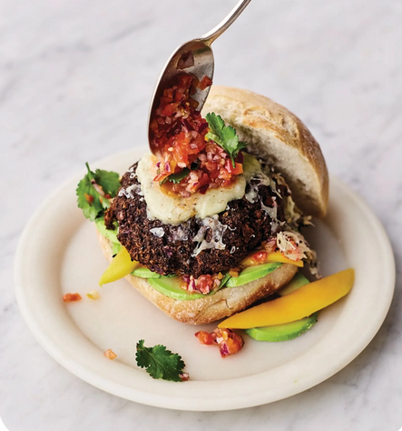
Roasted black bean burgers (V)
serves 4, kcals 499, fibre 12.5g
- 1½ red onions
- 200g mixed mushrooms
- 100g rye bread
- ground coriander
- 1 x 400g tin of black beans
- olive oil
- 40g mature Cheddar cheese
- 4 soft rolls
- 100g ripe cherry tomatoes
- 1 lime
- chipotle Tabasco sauce
- 1 ripe mango
- 1 ripe avocado
- 4 tablespoons natural yoghurt
- 4 sprigs of fresh coriander

- Preheat the oven to 200ºC/400ºF/gas 6.
- Peel 1 onion, place in a food processor with the mushrooms, rye bread and 1 teaspoon of ground coriander, and whiz until fine.
- Drain and pulse in the black beans, season lightly with sea salt and black pepper, then divide into 4 and shape into patties, roughly 2.5cm thick.
- Rub all over with oil and dust with ground coriander, then place on an oiled baking tray and roast for 25 minutes, or until dark and crispy, topping with the Cheddar and warming the rolls for the last few minutes.
- Meanwhile, peel and very finely chop the remaining onion with the tomatoes and place in a bowl. Squeeze over the lime juice, add a few shakes of Tabasco and season to taste. Destone, peel and finely slice the mango and avocado.
- Halve the warm rolls and divide the yoghurt between the bases, followed by half the salsa, the mango, avocado and coriander leaves. Top with the burgers, remaining salsa and extra Tabasco, pop the lids on and press down lightly. Always nice with oven-roasted, skin-on chips.

https://www.jamieoliver.com/recipes/vegetables/roasted-black-bean-burgers/

