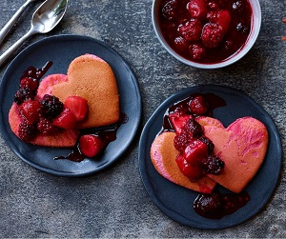
Valentine's pink pancakes (V)
Serves 2, 527kcal, Fibre 7g
For the compote
- 150g frozen mixed berries
- 1½ tbsp icing sugar, plus extra for dusting
- ½ tsp vanilla bean paste
- ½ orange, zested and juiced
For the pancakes
- 1 tsp baking powder
- 155g pancake shaker mix
- pink food colour gel
- 20g butter, cubed

- First, tip all the compote ingredients into a small saucepan and bring to the boil. Reduce to a simmer and cook for 8-10 mins, stirring occasionally, until the sauce is syrupy but the berries are still holding their shape. Set aside.
- Next, make the pancakes. Add the baking powder to the shaker, reseal and shake to combine. Pour 180ml of water and a generous squeeze of the pink food gel into the mix, reseal and shake for 2 mins until smooth. If you would like the batter to be a more vibrant pink, squeeze in an extra drop of food gel at this stage and shake to combine.
- Add a cube of butter to a large, nonstick frying pan over a medium-high heat and, working in batches, pour the batter into the pan to create roughly 8cm pancakes. Cook for 1-2 mins until bubbles appear in the batter. Flip and then cook for a further 1-2 mins until risen and fluffy. Repeat with the remaining mixture.
- Cut the pancakes into hearts using an 8cm heart-shaped cookie cutter. (if you don’t have a cutter, leave as are) Stack the pancakes on a plate, drizzle with the compote and dust with icing sugar to serve.

