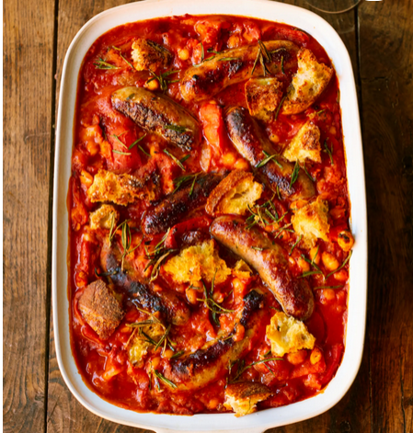
Comforting sausage bake
Serves 4, kcals 571, fibre 9.4g
- 600g ripe mixed-colour cherry tomatoes
- 4 cloves of garlic
- 200g rosemary focaccia
- 1 x 660g jar of white beans
- 12 chipolatas

- Preheat the oven to 180ºC/350ºF/gas 4.
- Halve the cherry tomatoes, peel and finely slice the garlic, and tear the bread into bite-sized chunks.
- Place it all in a 30cm x 35cm roasting tray, pour in the beans and their juice, drizzle with 1 tablespoon each of olive oil and red wine vinegar, add a splash of water, and mix it all together.
- Quickly pinch and twist each chipolata in the middle to make it into two mini ones, then randomly dot them around your bake, lightly pressing them into the beans and tomatoes.
- Roast for 45 minutes, or until everything is golden, bubbling and delicious.

This is a proper mix and match and use what you have got recipe, we used chipolatas but you could use any sausages, even veggie ones. You can swap in any type of bean you’ve got in the cupboard, jarred or tinned, or even lentils. No fresh tomatoes? Don’t worry, chuck in some tinned tomatoes or passata instead.

https://www.jamieoliver.com/recipes/pork/comforting-sausage-bake/

