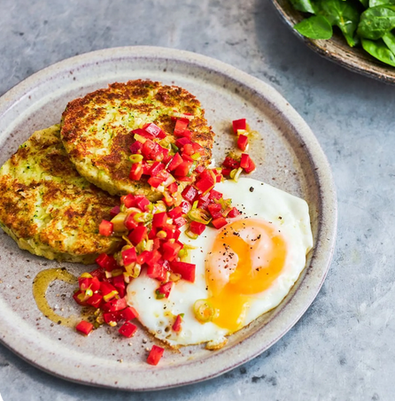
Smoky veg patties (V)
serves 4, kcals 403 fibre 6.8g
- 1 head of broccoli (375g)
- 1 bunch of spring onions
- 600g Maris Piper potatoes
- 1 red pepper
- 1 x 400g tin of cannellini beans
- 60g Cheddar cheese
- ½ teaspoon smoked paprika
- 4 large free-range eggs
- 1 x 80g bag of watercress, spinach & rocket
- olive oil
- red wine vinegar
- salt & pepper
- extra virgin olive oil

- Trim the tough end from 1 head of broccoli (375g). Finely chop the remaining stalk, then break the florets apart. Trim and finely slice ½ a bunch of spring onions.
- Peel and chop 600g of potatoes into 3cm chunks, then cook in a pan of boiling salted water for 12 minutes, or until tender, adding the broccoli florets for the last 3 minutes.
- Meanwhile, drizzle 1 tablespoon of olive oil into a large frying pan on medium heat, add the sliced spring onions and broccoli stalks and cook for 10 minutes, or until softened, then remove from the heat.
- Once cooked, drain the potatoes and broccoli and allow to steam dry, tip into the frying pan and leave to cool while you make the salsa.
- Deseed 1 red pepper and trim the remaining ½ a bunch of spring onions, then finely chop and place in a bowl with 1 tablespoon of red wine vinegar and a pinch of sea salt and black pepper.
- Drain and add 1 x 400g tin of cannellini beans to the frying pan, grate in 60g of Cheddar cheese, season with salt and pepper, then sprinkle in ½ a teaspoon of smoked paprika. Mash and mix together well, then divide into 8 equal-sized balls and pat into flat rounds.
- Place the frying pan back on a medium-high heat, drizzle in 1 tablespoon of olive oil, then add the patties and cook for 2 to 3 minutes on each side, or until golden and crisp, then remove (and keep warm) while you fry 4 eggs to your liking.
- To serve, place two patties and a fried egg on each plate, then top each with a spoonful of salsa. Serve 1 x 80g bag of watercress, spinach & rocket on the side and toss with a little extra virgin olive oil and red wine vinegar, if you like.

https://www.jamieoliver.com/recipes/vegetables/smoky-veg-patties/

