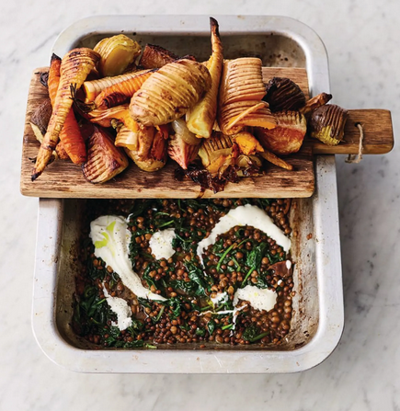
Hasselback al Forno (V)
serves 4, kcals 584, fibre 18g
- 1 large parsnip
- ½ a butternut squash (600g)
- 1 onion
- 2 beetroots
- 4 carrots
- 4 potatoes
- 2 cloves of garlic
- ½ a bunch of fresh thyme (15g)
- olive oil
- 2 tablespoons white wine vinegar
- 100ml Chianti red wine
- 2 x 400g tins of green lentils
- 100g baby spinach
- 4 tablespoons natural yoghurt

- Preheat the oven to 200ºC/400ºF/gas 6.
- Scrub or peel all the veg: quarter the parsnip, squash and onion and halve the beetroot (try to choose medium-sized carrots and potatoes, but use your common sense and slice any larger ones in half).
- One at a time, place the veg on a board between the handles of two wooden spoons, so that when you slice down into them the spoons stop the blade from going all the way through. Carefully slice at just under ½cm intervals all the way along, putting the veg into a large roasting tray as you go.
- Peel the garlic and place in a pestle and mortar, strip in the thyme leaves, then bash to a paste and muddle in 6 tablespoons of oil, the vinegar, and a pinch of sea salt and black pepper. Toss well with the veg, then roast for 1 hour, or until golden and caramelised, turning halfway.
- Remove all the veg to a board and place the tray over a medium heat on the hob. Pour in the wine and leave to bubble and cook away, scraping up all the sticky caramelised bits from the bottom of the tray.
- Tip in the lentils (juices and all) and spinach, then stir until the juices have thickened and the leaves have wilted.
- Season to taste with salt and pepper, ripple through the yoghurt, then present to the table with the board of veg.

https://www.jamieoliver.com/recipes/potato/hasselback-al-forno/

