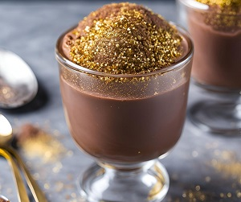
Chocolate and olive oil mousse (V)
Serves 2, 462kcal, Fibre 4.9g
- 100g bar 70% dark chocolate
- 2 eggs, separated
- 20g caster sugar
- 1 tbsp olive oil
- sea salt
- gold edible glitter, to decorate

- Melt the chocolate in a heatproof bowl set over a pan of simmering water, making sure the water doesn't touch the bowl. Remove the bowl from the pan; set aside for a few mins to cool.
- Put the egg whites in a mixing bowl with a pinch of sea salt and whisk to soft peaks.
- Tip the sugar into a separate mixing bowl and add the egg yolks. Whisk until pale and fluffy. Pour in the olive oil, mix well, then stir in the melted chocolate.
- Add a large spoonful of the egg white to the chocolate mixture and gently fold together, being careful not to overwork the mixture. Add the remaining egg white and gently fold until completely mixed. Divide between 2 glasses and chill for 1hr to set.

