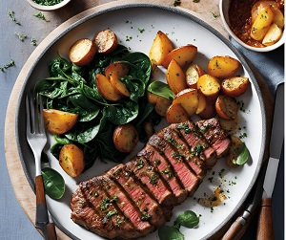
Paprika and thyme steaks with sautéed potatoes
Serves 2, 736kcal, Fibre 5.1g
- 2 x 225g beef sirloin steaks
- 1 tbsp olive oil
- 1 tsp smoked paprika
- 10g thyme, leaves picked
- 300g miniature potatoes
- 2 tsp soft butter
- 2 garlic cloves, finely sliced
- 240g bag baby spinach
- 50ml sherry

- Place the steaks in a shallow dish with 1 tsp of the olive oil, the paprika, thyme and a good twist of black pepper. Rub the seasonings into the meat, then set aside to marinate.
- Put the potatoes in a pan of boiling water and simmer for 20 mins or until tender. Drain and halve.
- Heat the remaining 2 tsp oil in a large frying pan and add the potatoes. Sauté for 15-20 mins until golden. Add the garlic for the final min.
- Heat another frying pan or a griddle pan until very hot. Cook the steaks for 3 mins each side for rare, 4 mins each side for medium, or 5 mins each side for well done. Transfer to a warm plate, cover with foil and set aside for 10 mins to rest.
- Meanwhile, put the spinach and sherry in a large saucepan, cover and wilt over a medium heat for 2-3 mins; drain and season.
- Serve the spinach with the steak, potatoes and a drizzle of the resting juices.

