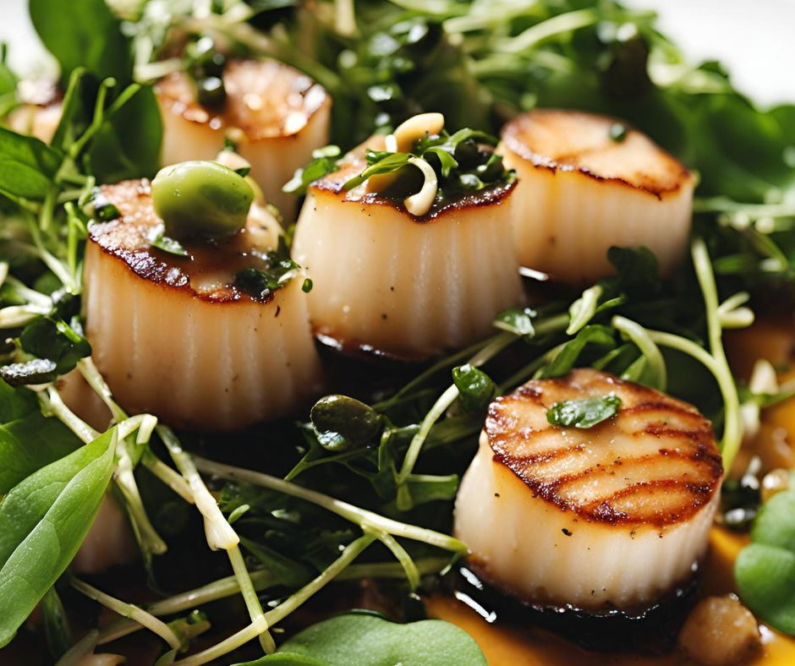
Scallops with brown butter, capers and tarragon
Serves 171kcal Fibre 0.6g
- 6 fresh whole scallops (about 150g, from the fish counter), or 6 frozen scallops, defrosted thoroughly
- ½ tsp olive oil
- 20g soft butter
- 1 tbsp chopped fresh tarragon
- 1 tbsp capers
- 30g watercress
- lemon wedges, to serve

- If using fresh scallops, trim the small white muscle off the scallops, leaving the orange coral intact. If using defrosted frozen scallops, simply pat dry thoroughly with kitchen paper. Rub the scallops with the oil and a pinch of salt.
- Heat a nonstick frying pan until hot, sear the scallops for 2 mins each side (or 2½ mins if using defrosted frozen scallops), then remove from the pan. Take the pan off the heat, add the butter, tarragon and capers, and swirl until the butter is a light golden brown.
- Divide the watercress between 2 plates and top with the scallops. Pour over the butter sauce and serve with the lemon wedges.

https://realfood.tesco.com/recipes/scallops-with-brown-butter-capers-and-tarragon.html

