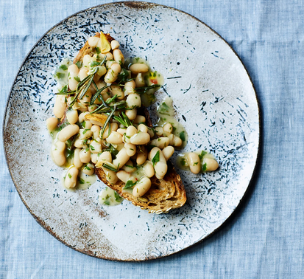
Garlic & chilli baked beans (V)
serves 4, Kcals 220, fibre 14g
- 4 cloves of garlic
- ½ a bunch of fresh rosemary
- olive oil
- ½ teaspoon dried red chilli flakes
- 2 x 400g tins of cannellini beans (or other tinned beans of your choice)
- ½ a bunch of fresh parsley
- red wine vinegar
- 1 lemon

- Peel and finely slice the garlic, then pick and finely chop the rosemary leaves.
- Heat a splash of oil in a frying pan over a medium heat, then fry the garlic, rosemary and chilli until the garlic is golden. Remove a few spoons of fried rosemary to use as garnish.
- Stir in the tinned beans, along with their juices, then let everything cook and reduce for about 5 minutes, or until thick and delicious. Meanwhile, finely chop the parsley.
- Add a glug of vinegar to the beans and season to taste.
- Finish with the chopped parsley and a good squeeze of lemon juice, drizzling over a little cold-pressed olive oil, if you like.
- Serve the beans on toasted sourdough bread, or as a side dish to grilled fish or roasted chicken, sprinkled with the reserved crispy rosemary.

https://www.jamieoliver.com/recipes/vegetables/garlic-chilli-baked-beans/

