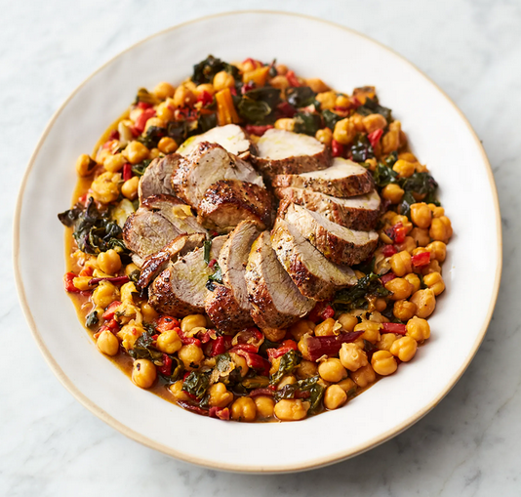
Chickpea chard pork
Serves 4 Kcals 325, fibre 5.6g
- 400g pork fillet
- 1 x 480g jar of roasted peeled peppers in brine
- 300g rainbow chard
- 1 heaped teaspoon fennel seeds
- 2 x 400g cans of chickpeas

- Put a large shallow casserole pan on a high heat. Season the pork with sea salt and black pepper, then place in the pan with 1 tablespoon of olive oil and sear for 5 minutes, turning halfway.
- Meanwhile, drain the peppers and quickly dice into 1cm chunks, then trim and finely slice the chard, stalks and all.
- Remove the pork to a plate, then add the fennel seeds, peppers and all the chard to the pork fat left behind in the pan. Stir and fry for 2 minutes, then pour in the chickpeas and their juice, stir, and bring to the boil.
- Sit the pork back in so it’s touching the base of the pan, pour over any resting juices, cover, and simmer gently on a medium heat for 12 minutes, or until the pork is just cooked through and it all smells incredible, turning the pork occasionally.
- Rest for 2 minutes, slice the pork, season the chickpeas to perfection, adding a splash of red wine vinegar, drizzle with extra virgin olive oil, and serve.

This works brilliantly with chicken thighs

https://www.jamieoliver.com/recipes/pork/chickpea-chard-pork/

